（ 七 ）年级 （ 英语 ） 学科集体备课
Unit 4 Finding your way |  | 第1课：  Comic strip and Welcome to the unit |  |  |  | 总课时 | 7
备课时间 | 月 日 | 主备人 |  | 执教教师 |  | 总课时 | 7
集体备课教案 |  |  |  |  |  | 个性化批注
教学目标：
1. 能在课堂活动中用简短的英语进行交际。
2. 能就熟悉的话题进行简单的交流。
3. 能在教师的指导下参与简单的游戏和角色扮演活动。
4. 能提供有关个人情况和个人经历的信息。
教学重难点：
- 能认识有关地点和交通的图标。
- 能谈论出游和交通方式的话题。
- 能辨别方位。
教学步骤：
Welcome to the unit
Step Ⅰ Free talk
- Ask and answer:(about directions)
Where do some birds fly in winter?
Where do they fly in spring?

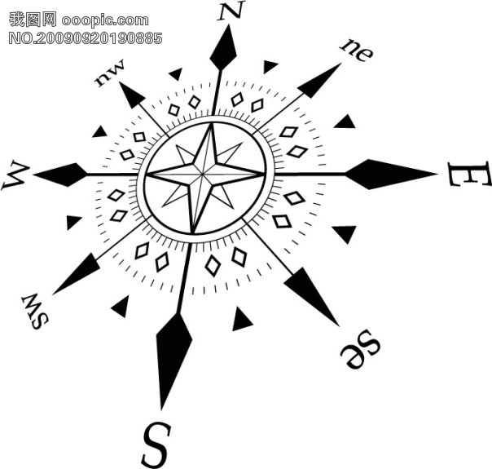
New words: south north east west south-east north-west south-west north-east.
- Ask and answer:
Where’s the park?
The park is north of our school.
Step Ⅱ Practice
Step Ⅲ Presentation
Step Ⅳ Practice
StepⅠPresentation
Work in pairs. Suppose one knows the way, and the other doesn’t. Please have a conversation about this.
Step ⅡListen and answer
- Listen to the tape and answer the question:
Does Hobo, in fact, know the way?
(No, he doesn’t.)
- (1)Where are Hobo and Eddie? (They’re on a hill.)
(2)How does Hobo go down the hill?(Hobo jumps down.)
Step Ⅲ Read and act
- Listen again, Ss read after the tape recorder.
- Ask some students to act it out, and they can use their own ideas in the conversation.
Step Ⅳ Homework
- Recite the dialogue and Part B.
- Complete WB.
- Preview Reading.
教学反思

