东台市梁垛镇中学2015-2016学年度第二学期第一次阶段检测八年级英语
友情提醒：请同学们把答案写在答题卡和答题纸上
第一部分 选择题
一、听力：（20分）(每小题1分)
A)听下面10段对话，每段对话后有1个小题，从题中所给的A、B、C三个选项中选出最佳选项。每段对话读两遍。
1. Which place are they talking about?
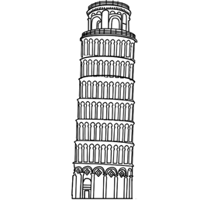
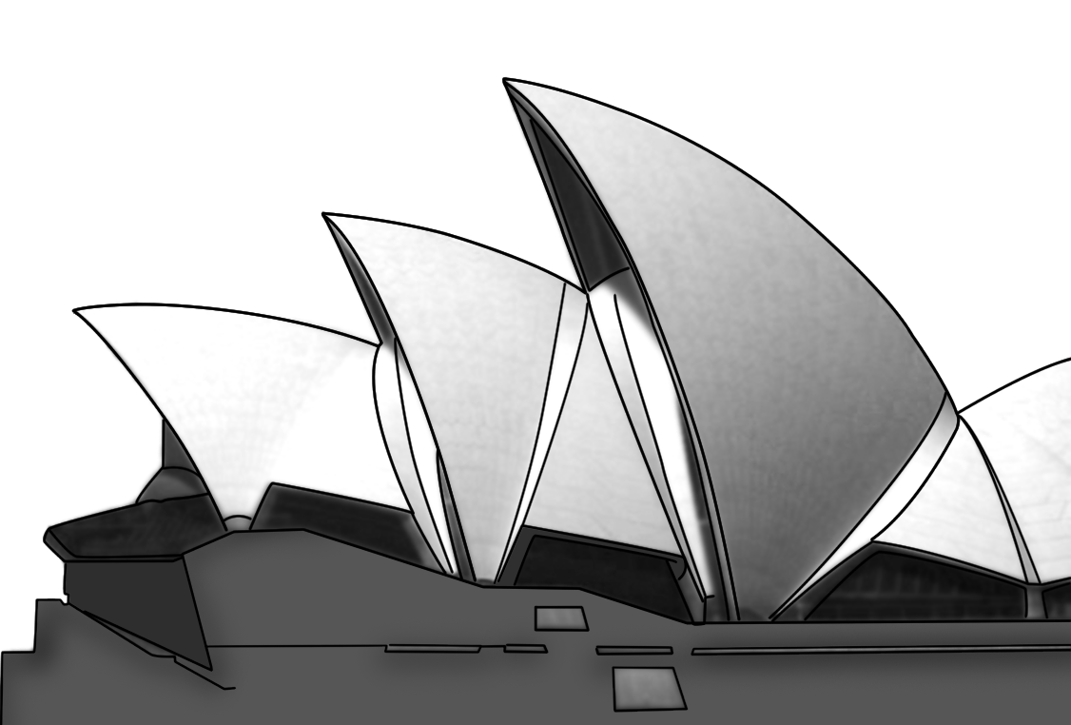

A. B. C.

2. Where has the woman been?
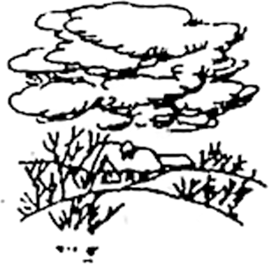
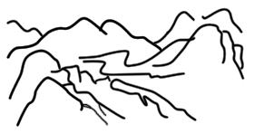
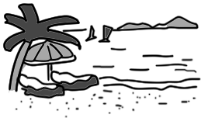
A. B. C.

3. What did the man’s family do last night?
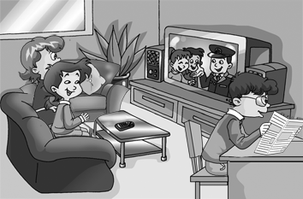
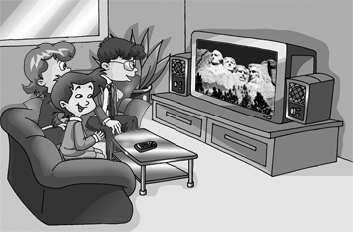
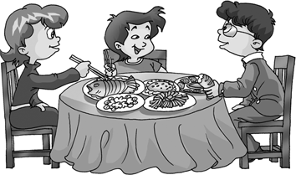
A. B. C.

4. What are they talking about?




A. B. C.

5. Where does the girl’s father work now?
A. In Canada. B. In the USA. C. In France.
6. What time will Mr. Wang leave for the theatre?
A. At 6.45. B. At 7.00. C. At 7.15.
7. Why hasn’t Helen finished her Maths homework?
A. She is too busy. B. She isn’t able to do it. C. She has forgotten to do it.
8. What does the woman mean?
A. She hates Japanese food.
B. She doesn’t want to go to the restaurant with the man.
C. She wants to pay this time.
9. How does the woman feel about her job?
A. She doesn’t like it very much.
B. She wants to do her work well.
C. She hates working at her office.
10. On which floor is Mr. Gao’s office?
A. The sixth floor. B. The ninth floor. C. The fifth floor.
B) 听下面一段对话和两篇短文，每段对话和短文后有几个小题，从题中所给的A、B、C三个选项中选出最佳选项。每段对话和短文读两遍。
听一段对话，回答第11-12小题。
11. When is Alice going to Bill’s house?
A. On Thursday. B. On Saturday. C. On Sunday.
12. What does Alice think is a helpful way for Bill to learn English well?
A. To talk with foreigners. B. To make cards. C. To listen to tapes.
听第一篇短文，回答第13-15小题。
Customs of New Year’s Eve
Italy | People 13 the old things.
Spain | 14 people come to the streets together.
Japan | People eat 15 on New Year’s Eve.
13. A. sell B. take out C. throw out
14. A. In the evening B. In the afternoon C. In the morning
15. A. dumplings B. noodles C. grapes
听第二篇短文，回答第16-20小题。
16. Where did the story happen?
A. At a cinema. B. In a library. C. At a shop.
17. Why was the woman angry?
A. Because she lost a piece of chocolate.
B. Because the man was talking loudly with his friend.
C. Because the man was looking for something and annoyed(干扰) her.
18. What was the relationship(关系) between the man and the woman?
A. They were husband and wife.
B. They were friends.
C. They didn’t know each other.
19. Why did the woman give the man a piece of chocolate?
A. Because the man wanted to eat more.
B. Because she wanted the man to keep quiet.
C. Because she wanted to let him go.
20. What did the man really want to find?
A. His glasses. B. His teeth. C. His movie ticket.
二、 单项选择（共15小题；每小题1分，满分15分）
（ ）21. My uncle ______ to Thailand. He’ll come back in two weeks.
A. goes B. went C. has gone D. go
（ ）22. I won’t go to the concert because I _______ my ticket.
A. lost B. have lost C. will lost D. lose
（ ）23. The Smiths used to live in London and now they _______ in Shanghai.
A. used to live B. are used to live C. are used to living D. are used for living
( ) 24. Mother asked me ______ computer games before finishing my homework.
A. not play B. to play C. not to play D. to not play
（ ）25. ---- Do you know Tom very well ?
----- Yes, he and I ______ friends since we met in Jiangyin in 2002.
A. have been B. became C. have made D. made
（ ）26. ---- When did you _______ ?
----- I’ve _________ for two months.
A. get married ; been married B. be married; been married
C. get married; got married D. get married ; married
（ ）27. ---- ______ you _______ your homework ?
----- Yes, I _______ it only a few minutes ago .
A. Did; finish; did B. Are; finished; did
C. Have; finished; did D. Have; finished; have done
（ ）28. We find it ______ for us to learn a foreign language well in such a short time.
A. impossible B. possible C. probably D. possibility
（ ）29. ---- Why did your parents buy a shiny golden silk dress yesterday ?
----- They bought it ______ me . It’s my birthday today !
A. at B. on C. in D. for
（ ）30. The place was so beautiful that her husband could not stop _____ photos. He took two hundred photos that day !
A. to show B. showing C. taking D. to take
（ ）31. Do you know the writer _______ Han Han.
A. call B. called C. calling D. to call
（ ）32. Everyone was _______ when they heard the _______ news.
A. exciting; exciting B. excited; exciting C. exciting; excited D. excited; excited
（ ）33. ----- How soon are you leaving for Beijing ?
------ In _______ days.
A. a couple of B. a couple C. a couple to D. a couple for
（ ）34. The teacher always reads a story for the children ______ a day .
A. in the end B. at the end C. in the end of D. at the end of
（ ）35. I ______ this magazine from the library last Friday, and have ______ it for more than a week.
A. lent ; kept B. borrowed ; borrowed C. borrowed ; kept D. kept ; borrowed
三、 完形填空(共10小题；每小题1分)
Mark lived in a village far away. One day he became very ill and everyone thought he would ___36___soon. They sent for a doctor. Two days___37___the doctor came and looked over the sick man. ___38___asked for a pen and some paper to write down the name of the medicine. But there was no pen___39___paper in the village because no one could write.
The doctor___40___ up a piece of burnt wood from the fire and wrote the name of the medicine (药) on the___41___of the house. "Get this medicine for him," he said, " and he will soon get ___42___."
Mark's family and friends did not know___43___to do. They could not read the strange words. Then a young man ___44___ an idea. He took off the door of the house, put it on his carriage (四轮马车) and drove to the nearest___45___. He bought the medicine there, and Mark was soon well again.
( )36. A. wake B. cry C. move D. die
( )37. A. late B. later C. ago D. before
( )38. A. The sick man B. Mark C. The doctor D. The farmer
( )39. A. and B. or C. then D. also
( )40. A. picked B. held C. made D. looked
( )41. A. wall B. window C. ground D. door
( )42. A. well B. worse C. bad D. good
( )43. A. when B. what C. where D. which
( )44. A. thought B. hit C. caught D. had
( )45. A. shop B. farm C. hospital D. village

四、阅读理解 （共15小题；每小题1分）
A
New York is one of the last large American cities to have some of its policemen on horseback. The New York police have 170 horses working in certain parts of the city. The horses are expensive to feed, but it is even more expensive to look after them. Because the horses must walk on the streets, they need special horseshoes. In fact, they need more than 8,000 of them each year. Every police horse in New York gets new shoes every month. Keeping these shoes in good repair is the job of six blacksmiths. There are only about thirty-five of these blacksmiths in the whole United States.
The cost of shoeing a horse is between twenty dollars and thirty-five dollars, and it takes a good blacksmith two or three hours to do the job.
A blacksmith's job is not an easy one. He must be able to shape a shoe from a piece of metal and then fit it to the horse's foot. The blacksmith must bend over all the time when he is fitting the shoe and must hold the weight of the horse's leg while he works. Clearly, a blacksmith must be very strong. But even more important, he must be able to deal with horses——for before the blacksmith can begin his work, he has to get the horse to lift its leg.
One of the blacksmiths in New York is James Corbin. He came to the country from Ireland in 1948. He not only makes horseshoes for the police but also works for a group of horse owners near the city. Corbin became interested in blacksmithing because his father did it, and，as the puts it, “It’s a good way to make a living.”
( )46. According to the reading passage， a blacksmith must be likely a______ man.
A. clever B. rich C. strong D. lucky
( )47. James Corbin became a blacksmith because he__________.
A. was interested in horses B. was needed by the policemen
C. drew a picture of the horseshoe D. had a make a living
( )48. In the reading passage “to shape a shoe” is to__________.
A. fit it on the horse's foot
B. use it for two or three hours
C. make the from of a horseshoe from a piece of metal
D. draw a picture of the shoe
( )49. The best title for the passage is “__________."
A. Policemen on Horseback B. Blacksmiths and Horseshoeing
C. James Corbin，a Blacksmith D. Horseshoeing is a Good Way to Make a Living
( )50. Which of the following is true？
A. Only a few large American cities have some policemen on horseback.
B. New York is the only city in America to have some policemen on horseback.
C. Policemen on horseback enjoy travelling around the United States.
D. Policemen on horseback are less expensive than those in cars.
B.
Imagine the situation. You are driving along a desert or on a mountain. You have no idea where you are. You passed the last house two hours ago. Then your car breaks down. It is night and it is cold. You have no mobile phone. What do you do? Well, next time take a GPS with you. This invention may be able to help you. It is a device(装置) which uses satellites (卫星) to find the user’s position(位置). It can find your position to within 20 metres. A GPS cannot start your car, but at least you will know where you are.
GPS, which means Global Positioning System, is a small radio receiver. It looks like a mobile phone. You can hold it in your hand, or put in your pocket. It is sometimes put into a watch or a telephone. We also find GPS devices in cars, planes, or boats. Some of these devices have electronic maps, so you know where you are. For example, in a city they can tell you the name of the street.
There are three parts to the Global Positioning System. The first part is the receiver. You can hold it in your hand, or have it fixed into your car, plane, etc. The second part is a group of satellites orbiting the Earth. The receiver contacts at least four of the satellites and calculates(计算) its position. The third part of the system is a network of ground stations. They are all over the world. They control the satellites and make sure they are working well.
Some people think that in the future the GPS will be as common as the mobile. They are becoming cheaper and more and more accurate(精确的). There are also new uses for the GPS. Perhaps they will become like watches. Everyone will have one and you will never be lost again.
( )51. According to the passage, with the help of the GPS, people __________.
A. can’t be lost in a new city
B. can’t find their way in different countries
C. can learn about the culture of an unknown place
D. can spend the least time getting to another place
( )52. We can learn from the passage that ____________.
A. there are three parts to the GPS
B. a GPS can’t be put into a watch
C. a GPS can help you start your car
D. the GPS are becoming more and more expensive
( )53. The underlined word “They” in paragraph 3 means “____________”.
A. Receivers B. GPS devices C. Satellites D. Ground stations
( )54. The passage is mainly about _______________.
A. the history of the GPS B. the introduction of the GPS
C. the shape of the GPS D. the three parts of the GPS
( )55. What can we infer(推断) from the passage?
A. All GPS devices have electronic maps.
B. People in many countries will use the GPS for free.
C. The receiver of the GPS contacts at least five of the satellites.
D. The GPS will become more and more common in everyday life.
C
There was a lovely vegetable patch (菜园). A large tree grew there. Both the patch and the tree gave the place a wonderful look, and they were the pride of the gardener. But no one know that the vegetables and the tree couldn’t stand (忍受) each other. The vegetables hated the tree’s shadow (阴影) , because it left them only just enough light to live. The tree, on the other hand, hated the vegetables because they drank nearly all the water, leaving him just enough to live.
The situation became so serious that the vegetables decided to use up all the water in the ground so that the tree would die. The tree answered back by not protecting t he vegetables from the hot sun, so they began to dry up. Soon the vegetables were really weak, and the tree was drying up.
The gardener wondered why and stopped watering them. When he did that, both the tree and the vegetables realized that it was better to help each other. They lea rned how to live in harmony with those around them. So they decided to work together, using both the shade and the water to grow well. After seeing how well they were doing, the gardener gave the best care to the vegetable patch, watering and fertilizing (施肥) it better than any other patch for miles around.
( )56. Why didn’t the vegetables and the tree get on well with each other?
A. Because the vegetables wanted more light.
B. Because the tree drank almost all the water.
C. Because the vegetables weren’t the pride of the gardener.
D. Because the vegetables didn’t look as wonderful as tree.
( )57. From the passage we know ______.
A. The vegetables were sorry to see the tree drying up.
B. The gardener was very angry with the vegetables and the tree.
C. The gardener didn’t know what was happening in the patch at first.
D. The tree didn’t know how important the sun was to vegetables.
( )58. The underlined phrase “in harmony” means “______” in the Chinese.
A. 长久地 B. 小心地 C. 有效地 D. 和谐
( )59. Of the following, which order is right according to the story?
① The gardener worked on the patch e ven harder than before.
② The gardener stopped watering the vegetables and the tree.
③ The vegetables decided to use up all the water in the ground.
④ The tree and the vegetables realized the important of helping each other.
A. ③②④① B. ④②③① C. ②①④③ D. ①③④②
( ) 60. The passage is mainly about _______.
A. why the sunlight and water were very important
B. how the gardener took care of his vegetable patch
C. why the gardener was proud of his vegetable patch
D. what happened between the vegetables and the tree
第二部分 主观题
五、词汇 （共15小题；每小题1分，满分15分）
(A) 根据句意,首字母及中英文提示写出正确的单词：
61.Danny and Daniel are brothers , and their _______ ( 妻子 ）are sisters.
62.You should do something to improve the __________(情况).
63.Finally the villagers _______ (意识到) how serious the problem was .
64.-Have you ever been a______?
-Yes, I went to America and Australia last year.
65.He has a big family, so he has many r______.
(B)用所给词的其适当形式填空：
66. On his ________ (twenty) birthday, he went to the museum with his parents.
67.He went _________ ( sail ) in Hainan Island last summer.
68.Jim has already _________ (forget) his English teacher’s name.
69.They are going to take a direct _______ ( fly ) to New York.
70.Water ______ ( pollute) is one of the biggest problems in the world now.
(C)从方框中选择合适的动词，并用其正确时态填空：
71.-Turn off the radio, dear. The baby is sleeping.
-There is no need. He ______ (wake) up.
72.I _____ (leave) my key in the taxi, and now I can’t get into my home.
73.Mr Wang _______ (repair) your car. Look,it looks as good as a new one.
74.Mum makes us breakfast every morning, so she is used to _______(get) up early.
75.When _______ he _______ (return) from the USA.

六、任务型阅读（共5小题；每小题1分，满分5分）
I have a friend named Monty Roberts who owns a horse ranch (牧马场). The last time I was there he told me his story.
When he was young, his family is too poor to have a house to live in. One day when he was in a high school, he was asked to write a paper about what he wanted to be and do when he grew up. That night he wrote a seven-page paper describing his goal of owning a horse ranch. He also drew a picture to show a 4,000-square-foot house that would sit on a beautiful farm. The next day he handed it in to his teacher. Two days later he received his paper back. On the front page was a large red F. Roberts asked, “Why did I receive an F?” His teacher said, “This is an unrealistic (不现实的) dream for a young boy like you. Owning a horse ranch requires a lot of money.” Then the teacher added, “ If you rewrite this paper with a more realistic goal, I will reconsider (重新考虑) your grade.”
The boy went home and thought about it for a long and hard time. He asked his father what he should do. His father said, “Look, son, you have to change your own mind on this.” Finally, after sitting with it for a week, the boy handed in the same paper, making no changes at all. He told his teacher “You can keep the F and I still keep my dream.”
Monty said a lot of kids’ dreams can be stolen. Don’t let anyone steal your dream. Follow your heart, no matter what others think. Have enough gumption (毅力) till your dream comes true.
76. Who owns a horse ranch? _______________________________________
77. What was the boy’s dream? _______________________________________
78. When did he hand in his seven-page paper to his teacher? ___________________
79. Why did his teacher give him an F? _______________________________________
80. What will you do to make your dream come true? ________________________

七、补全短文（共10空；每空1分，计10分）
Mr Brown went swimming with his friends one afternoon. They all put on their swimming trunks(游泳裤)except him because he t—81—there would be some p---82---for the swimmers to change clothes near the beach. However, when they got to the beach , he f–83—nowhere to change clothes. So Mr Brown had to go to a car and changed his clothes in it. But while Mr Brown was p-–84---on his swimming trunks , an old woman c-–85—near and stood by the car. Mr Brown h---86--- to be quiet. Then he o---87---the door of the car and shouted a-–88—to the woman ,”Do you always w-–-89— people change their clothes?’ The woman shook her head and said ,”Do you always change your clothes in o--90—people’s car?”
81.__________82. __________83. __________84. __________85. __________
86__________ 87___________88___________ 89__________ 90___________

八、书面表达 （10’）
假如李家湾（Lijiawan）是对外开放单位，请用英语为来访外宾写一篇短文，介绍
该村的简况。
要点如下：（词数80个左右）
1. 李家湾远离城镇，有2,000多人口；
2. 过去这里没有工厂、学校,村民们（villagers）生活艰苦；
3. 1990年以来该村发生了很大的变化；
4. 现在村里已有两家工厂和一所学校；
5. 村民们都住进了新居,生活越来越好。
6. 这些变化给这个镇带来了优势，但也导致了很多问题。空气污染比其它镇多。
________________________________________________________________________________________________________________________________________________________________________________________________________________________________________________________________________________
八年级英语听力原稿及答案
一、听力（共20小题；每小题1分，满分20分）
A)听下面10段对话。每段对话后有1个小题，从题中所给的A、B、C三个选项中选出最佳选项，每段对话读两遍。
1. W: Look at the picture, It’s a place of interest in Beijing.
M: Yes. And it’s becoming more and more beautiful. The Olympic Games were held here in 2008.
2. M: You’ve just come back from Hainan Island. What’s it like there?
W: It’s a fantastic place. It is the second largest island in our country. It has some beautiful beaches.
3. W: What were you doing at about 8:00 last night?
M: I was watching TV.
W: How about your parents?
M: Well, Mom was watching TV, too. But Dad doesn’t like soap operas. He was reading a newspaper.
4. W: Would you mind not smoking here?
M: Oh, sorry! I’ll put it out right away.
W: It’s not allowed in public place. You can smoke in smoking room.
M: OK. Thanks.
5. M: I hear your father works in Paris.
W: No. That was five years ago. Since then he’s worked in New York.
6. W: Hi, Mr Wang! I’ll leave for the theatre at 7 o’clock.
What about you?
M: I have no bike. I’ll have to leave 15 minutes earlier.
7. M: Have you finished your Maths homework, Helen?
W: Not yet. I really don’t know how to do it.
8. M: There is a good Japanese restaurant nearby. Would you like to go there for lunch?
W: Yes, but it’s my treat this time. You don’t need to take any money with you.
9. M: You seem to have a lot of work to do in your office.
You’re always staying late.
W: That’s true. I’m new here. I should learn more about my new job.
10. W: Would you tell me where Mr Gao’s office is, please?
M: Sure. His office is on the sixth floor, but the lift only goes to the fifth. From there you can walk up the stairs to the sixth floor. It’s the ninth room on the right.
B) 听下面一段对话和两篇短文，每段对话和短文后有几个小题，从题中所给的A、B、C三个选项中选出最佳选项。每段对话和短文读两遍。
听一段对话，回答第11-12小题。
M: Hello, Alice. Could you please come to my house this Saturday?
W: What’ s up, Bill?
M: We had an English test last Thursday, but I only got 45. I need your help.
W: Do you read English aloud every day?
M: Yes, I do. But I forget most of it.
W: I think making cards may help you improve your English.
M: Sounds interesting.
W: OK. I’ ll come to your house and tell you some more ways to learn English well.
M: Thanks a lot. See you on Saturday.
W: See you.
听第一篇短文，回答第13-15小题。
On New Year’s Eve, people in Italy throw out all the old things. So there are chairs, beds, clothes and plates in the streets. In Spain, the New Year comes more quickly. In the evening, people come to the streets together. Each holds a bag of grapes. When twelve o’clock comes, people start eating the grapes. In Japan, people eat noodles on New Year’s Eve. This food is said to bring long life. Early in the next morning, some families climb Mount Fuji. There they watch the first sunrise of the year.
听第二篇短文，回答第16-20小题。
A woman was at the cinema, and she was enjoying the movie very much, but there was a man in the next seat. He was looking for something. The woman was angry and said in a low voice, “What are you doing, sir? What are you looking for? Could you please keep quiet?”
“A piece of chocolate,” the man said, “I dropped it on the floor.”
“A piece of chocolate?” the woman said angrily, “It’s dirty now! Take this and be quiet.” She gave the man a big piece of chocolate.
“But,” the man said, “My teeth are in the piece of chocolate on the floor.”
一、听力答案
1-4 CBBA 5-10 BABCBA 11-15 BBCAB 16-20 ACCBB
二、单项选择（15分）
21-25 CBCCA 26-30 ACADC 31-35 BBADC
三、完形填空（10分）
36-40 DBCBA 41-45 DABDC
四、阅读理解（15分）
46-50 ADCBA 51-55 AADBD 56-60 ACDAD
五、词汇（15分）
A、61、wives 62、situation 63、realized 64、abroad 65、relatives
B、66、twentieth 67、sailing 68、forgotten 69、flight 70、pollution
C、71、has woken 72、have left 73、has repaired 74、getting 75、did return
六、任务型阅读（5分）
76、Monty Roberts.
77、To own a horse ranch and a 4,000-square-foot house.
78、 The next day.
79、 Because his teacher thought this was an unrealistic dream.
80、略
八、短文填空（10分）
81.thought 82.places 83.found 84.putting 85.came
86.quiet 87.opened 88.angrily 89.watch 90.other
九、参考答案（10分）
Lijiawan is far away from cities. There are two thousand people in it. There weren’t any factories or
schools in the past. Villagers lived a hard life. The village has changed a lot since 1990. Now there are
two factories and a school in the village. Villagers have moved into new houses. Their life is getting better
and better. These changes have brought many advantages, but they have also caused many problems for
people. There is more air pollution here than in any other town.

