东台市梁垛镇中学2015-2016学年度第二学期第一次阶段检测七年级英语
（试卷满分：100分 考试时间：100分钟）

第Ⅰ卷（选择题 共50分）
一、听力部分(共20分,每小题1分)
A) 听下面10段对话，每段对话听两遍。听完每段对话后，你都有10秒钟时间回答有关问题和阅读下一题。
( ) 1. When does the boy get up?
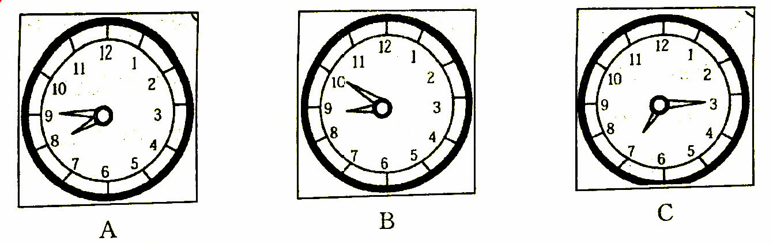
( ) 2.What day is Kate’s birthday?
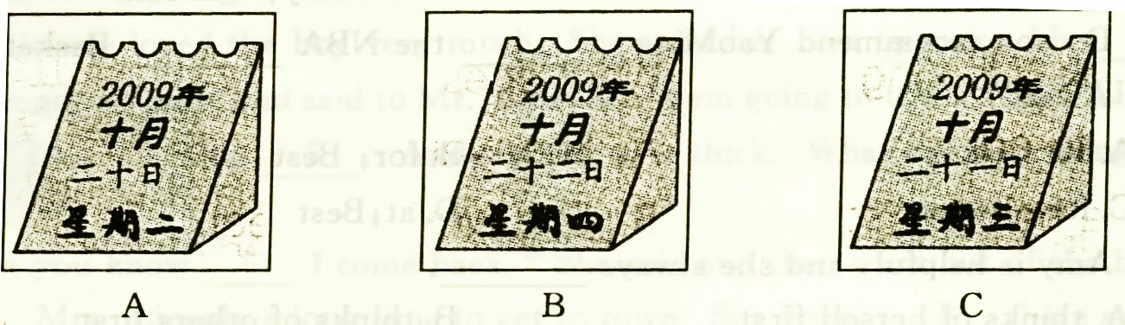
( ) 3.Which pair of shoes are they talking about?
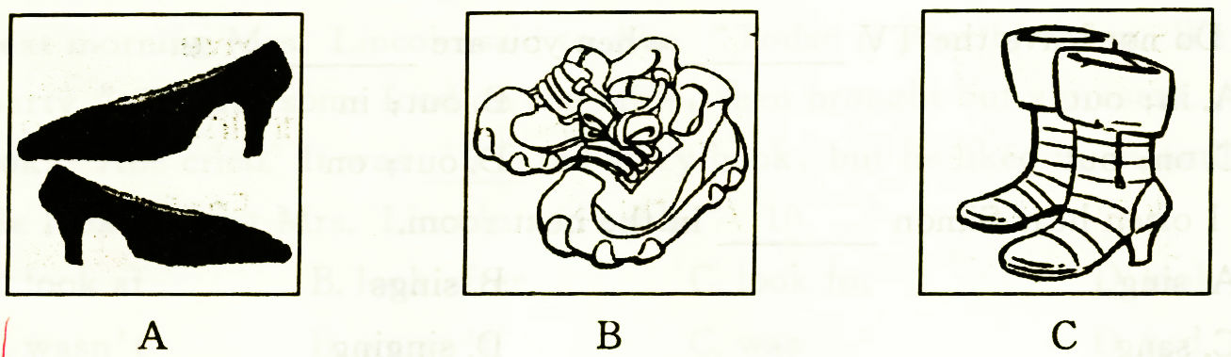
( ) 4.How does Tom get to school sometimes?
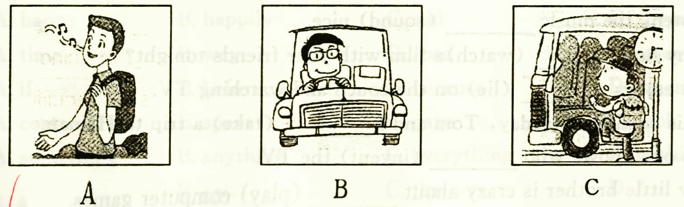
( ) 5.Who wants to buy a hat?
A. Lily. B. Ann. C. David.
( ) 6. What colour is Mr. Zhang’s tie?
A. Red. B. Pink. C. Blue.
( ) 7. How much does the watch cost?
A. 50 dollars. B. 24 dollars. C. 25 dollars.
( ) 8. When will they go to the library?
A. Next Monday. B. Next Tuesday. C. Next Wednesday.
( ) 9. What is Mary’s mother?
- A nurse. B. A doctor. C. A worker.
( ) 10.Why does the woman go to work by bus today?
A. She doesn’t like walking. B. Her bike is broken.
C. It is far away from her home.
B) 听对话及问题，回答第11至15题。听两遍。
( ) 11. A. At Tom’s home. B. In a shopping mall. C. In a library.
( ) 12. A. Yes, he is. B. No, he isn’t. C. Yes, he does.
( ) 13. A. They’re asking and answering the way. B. They’re helping each other.
C. They’re talking on the phone.
( ) 14. A. Harry has an exchange friend. B. Harry exchanges students with us. C. Harry comes from the UK.
( ) 15. A. There are 683319 people in the town. B. There are 638319 people in the town. C. There are 638391 people in the town.
C) 听下面一篇短文, 回答第16至20题，听两遍。
( ) 16. How is the future city in the writer’s eyes?
A. Big. B. Noisy. C. Modern.
( ) 17. How many floors do the buildings have in the future city?
A. 60. B. More than 60. C. Less than 60.
( ) 18. How do people travel from one place to another?
A. By bikes. B. By planes. C. By flying cars.
( ) 19. Who makes everything cheap?
A. People. B. Workers. C. Robots.
( ) 20. Who needs to pay for the things in the shopping centre?
A. Buyers. B. Nobody. C. Robots.
二、单项选择（共10分，每小题1分）
( )21. There is a big tall tree ____ our classroom. There are many apples ____ the tree.
A. in the front of, in B. in front of, on
C. in front of, in D. in the front of, on
( )22. We read 10,206 like this:______
A. one thousand, two hundred and six
B. one thousand, two hundreds and six
C. ten thousand, two hundred and six
D. ten thousands, two hundreds and six
( )23.—Do you have your own bedroom? — No, I share one ____ my sister.
A. to B. for C. with D. by
( ) 24. It is only 10 minutes from my new home to my school____.
A. by a bike B. on bike C. by bikes D. on a bike
( ) 25. — ____ we go to the zoo tomorrow afternoon? —Good idea.
A. Are B. Shall C. Do D. will
( ) 26. There are lots of books ____, so we are very busy.
A. read B. to read C. reading D. reads
( ) 27. There ____ a class meeting this afternoon.
- is going to have B. is going to be C. will have D. is going to
( )28. Nancy doesn’t ____ bedroom.
- has her own B. have her own C. has her own’s D. have her own’s
( )29. — Would you like to play games with me? — Yes, _____.
- I’d like B. I’d like to C. I like to D. I would like
( )30. Millie is a good swimmer, and she can swim ____ a fish.
A. likes B. is like C. like D. is likes
三、完形填空（共10分，每小题1分）
The telephone rings and Sue answers it. “ 31 I speak to Mrs Potts, please?” a man asks.
“I’m afraid you’ve got the wrong 32 ,”Sue says.
“I’m sorry,” the man says.
A few minutes later the telephone rings 33 .Sue 34 it. It is the same man. He makes a mistake again. Three minutes 35 ， the telephone rings once more, but she 36 answer it this time, It rings and rings. Her mother hears the 37 . “Why 38 you answer the phone, Sue? she calls.
“Oh, all right,” Sue says. “I’m sure it’s that man again.” But she is 39 . It is her father and he is very 40 . Sue keeps him waiting.
( )31. A．Shall B．Do C．Must D．May
( )32. A．number B．telephone C．person D．place
( )33. A．more B．again C．back D．soon
( )34. A．gets B．makes C．answers D．gives
( )35. A．ago B．before C．later D．past
( )36. A．goes to B．would like C．can’t D．doesn’t
( )37. A．sound B．voice C．noise D．telephone
( )38. A．do B．don’t C．can D．can’t
( )39. A．right B．correct C．wrong D．foolish
( )40. A．happy B．hungry C．angry D．tired

四、阅读理解（本大题共10分，每小题1分）
A
In some foreign countries, some people don't like the number 13．They don't think 13 is a lucky number．For example, they don't like to live on the thirteenth floor．
My friend Jack has got the same idea．He doesn’t like the number 13, either．
One day, my friend Jack asked some friends to dinner． Mr. and Mrs. came here, too． When all of his friends arrived, he asked them to sit around the dinner table．He began to count the people in his mind while they were having the delicious food．Suddenly, he cried out, “Oh, there are thirteen people here!” Everyone's face turned white except Mr. Brown．He said slowly with a smile on his face, “Don't worry, my dear friends．We have fourteen people here．My wife Mrs. Brown will have a baby in a few months．She's in the family way now．”
All of them became happy again．
“Congratulations!” they said to Mr. and Mrs. Brown．They enjoyed the nice food and had a good time that evening．
( )41. Some foreigners think the number 13 is ______．
A． lucky B． luckily C． unlucky D． unluckily
( )42. Mr. and Mrs. Brown were Jack’s ______．
A． parents B． friends C． classmates D． relatives
( )43. Everybody’s face turned white when they ______．
A． saw Jack B． saw the food C． heard the number 13 D． were drinking
( )44. The sentence “She is in the family way now” means ______．
A． she is going to have a baby B． she is at home
C． she is on her way home D． she is coming from home now
( )45. All of them became happy again because ______．
A． Mr. Brown told not to worry B． they enjoyed the delicious food
C． Mr. Brown would have a baby D． the number of people was 14 not 13
B
It was a very hot day in the middle of summer, and there were no trees along the street. Mr Read closed his shop at half past five, and went out into the street and began walking to the bus stop. He was very fat. The sun shone down on the street, and in soon Mr Read felt very hot.
A boy came out of another shop in the street and followed(跟随) Mr Read. He stayed very near him all the time, and he kicked (踢)Mr Read’s shoes several times, Mr Read looked at him angrily(生气地) each time.
After the fourth time, Mr Read stopped, turned around and said to the small boy, “what are you doing? Stop following me like that! You’re going to hurt(伤) my feet.”
“I’m sorry, but don’t stop me, please!”the boy said.“It’s very hot today and there isn’t any shade（阴凉处）in the street!”
( )46.It was ____ when the story happened(发生).
- hot B. not sunny C. cold D. cool
( )47. Mr Read _____ at about 5:30.
A. was going to take a bus B. was going home
C. was looking for a small boy D. was going to another shop
( )48. In a few minutes, Mr Read felt hot because _____.
A. he walked fast B. he was a fat man
C. he walked in the sun D. the small boy stayed very near him
( )49. What did Mr Read do after the boy kicked his shoes several times?
A. He stopped to walk. B. He told the boy to stop walking behind him.
C. He told the boy to walk in front of him.
D. He asked the boy not to hurt his feet.
( )50. The boy followed Mr Read because_____.
A. he could buy things in Mr Read’s shop B. he could cross the road safely
C. he could find the way home D. the sun wouldn’t shine down on him
第Ⅱ卷（非选择题 共50分）
五、任务型阅读（共10分，每空1分）
I am Lily. I have a piece of good news to tell you. We have a new apartment(公寓).The rooms are small, but they are all comfortable. There are more rooms here than in our old apartment. This is good because now I have my own room. In the old apartment, I must share a room with my sister.
My bedroom is my favourite in our apartment. I can be alone in it. I can read and draw. I can listen to music. I can play games and send my friends e-mails on my computer.
My second favourite room is the kitchen. I like helping my mother cook my meals. She is a very good cook and often teaches me how to make many different kinds of dishes. She lived in Morocco when she was a girl, and she can cook Morocco food. It is delicious.
根据短文内容，完成表格。
Lily’s apartment
The old apartment | It has fewer rooms and I share a room 51 my sister.
The new apartment | The rooms are small, but they are all 52 .
The new apartment | My favourite room is my 53 .I can be 54 in it. I can read and draw. I can listen to 55 .I can play games 56 my computer and send e-mails 57 my friends.  The 58 is my second favourite room. I can help my mother with 59 . My mother’s Morocco food is 60 .
51 ________ 52 ________ 53 ________ 54 ________ 55 ________
56 _______ 57 ________ 58 ________ 59 ________ 60 ________
六、根据短文内容，回答下面问题。(共10分,每小题2分)
My name is John. I want to tell you a story about my dog. A lot of people say that the dog is man’s best friend. I think so. My dog’s name is Jack. Jack has white and brown fur and big brown eyes. Jack is very loyal(忠诚的) and loves me very much. He follows me everywhere.
One day, Jack and I went for a walk by the river. It was cloudy but still warm. After five minutes, it started to rain. I decided to go home because I did not want to get wet. As Jack and I were running home, the rain became heavy. I could not see anything in front of me. Suddenly, I slipped(滑倒) and fell into the river. I am not good at swimming and I was afraid that I would die. At the moment, Jack jumped into the river, swam over to me and helped me out of the river. I climbed to the river bank, but I was too tired to move. Jack ran home to find my parents. They came and took me home. Jack saved my life. He is me hero(英雄).
61. Where did John and his dog take a walk one day?
________________________________________________
62. Why did John want to go home when he was having a walk?
________________________________________________
63. Was John good at swimming?
________________________________________________
64. Who saved John’s life?
________________________________________________
65. What is the story about?
________________________________________________
七、词汇运用（共10分，每小题1分）
A．根据句意、中文提示,写出句中所缺单词，使句子通顺。
66. Jack lives on the ________ (第十二) floor.
67. Our flat has two ________ (阳台).
68. The mall is five ________ (平方) meters in area.
69. Carl is one of the works in the ________ (社区) centre.
70. My elder brother is an ________ (工程师).
B．用所给单词的适当形式填空。
71. They have fun ________ (eat) beef in that restaurant every week.
72. Please ask him ________ (not be) late for class next time!
73. How long does it take them ________ (ride) to the museum?
74. He ________ (leave) for the USA next year.
75. Each of us ________ (speak) English very well.
八、根据短文内容及首字母提示,补全空格内单词，使短文完整、通顺。(共10分，每空1分)
Simon likes to s_76__ us around his home town. He l_77 in a small house. There is a small garden behind the house. His parents g_78__ vegetables and flowers in it.
There is a bus stop beside the garden. It t_79__ Simon about thirty minutes to get to the nearest town. There are l_80__ of buildings in the town. His f_81__ place is the youth centre. He often goes there a_82__ school. He likes g_83__ into town on his bike. Sometimes he goes swimming when it is warm and s_84__. There is not much air pollution in the town because cars can’t go into the c_85__ of the town.
76____________ 77____________78___________79______________ 80____________
81____________ 82___________ 83__________ 84______________ 85_____________
九、书面表达（共10分）
以“My home”为题，写一篇50词左右的作文，要包含以下要点：
- 我家不是很大，靠近海滩；
- 我家有三个卧室、一个客厅、一个厨房和两个卫生间；
- 我最喜欢的地方是阳台，因为我喜欢在那儿向外看海滩和大海；
- 我家门前有个大花园，是种花的好地方；
- 我经常邀请朋友们来我家，和我分享我的书。
具体要求：
1. 语句通顺，意思连贯，条理清楚，字迹工整。
2. 内容必须包括以上的要点，不一定要逐字翻译，可适当发挥。
______________________________ __________________________________________
________________________________________________________________________________________________________________________________________________________________________________________________________________________________________________________________________________________________________________________________________________________________________________________________________________________________________________________________________________________________________________ _______________________________________________________________
七年级英语答案
- 听力测试 (20分')
1-5 CABCA 6-10 BCCAB 11-15 ABCCC 16-20 CBCCA

二、单项选择（10分）
21-25 BCCDB 26-30 BBBBC

三、完型填空。（10分）
31-35 DABCC 36-40 DABCC

四、阅读理解（10分）
41-45 CBCAD 46-50 AABBD

五、任务型阅读( 10分)
51.with 52. comfortable 53. bedroom 54. alone 55.music
56.on 57. to 58.kitchen 59. cooking/ meals 60. delicious

六、阅读表达 (10分)
61. By the river.
62. It started to rain and he didn’t want to get wet..
63. No, he wasn’t.
64. Jack./ The dog.
65. 略

七、词汇运用 (10分)
66. twelfth 67. balconies 68. square 69. community 70. engineer
71. eating 72. not to be 73. to ride 74. will leave 75.speaks

八．短文填空。（10分）
76.showing 77. lives 78. grow 79. takes 80. lots
81.favourite 82. after 83. going 84. sunny 85. centre
九、书面表达 ( 10分)
略。

